Capture Running Python.

1. bikeshare.py >> Load CSV dataset mentah ke Postgresql.

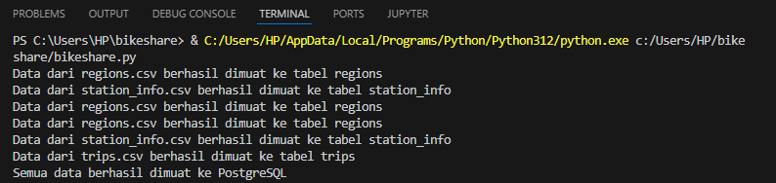

1. bikeshareSkema.py >> proses ETL to star skema

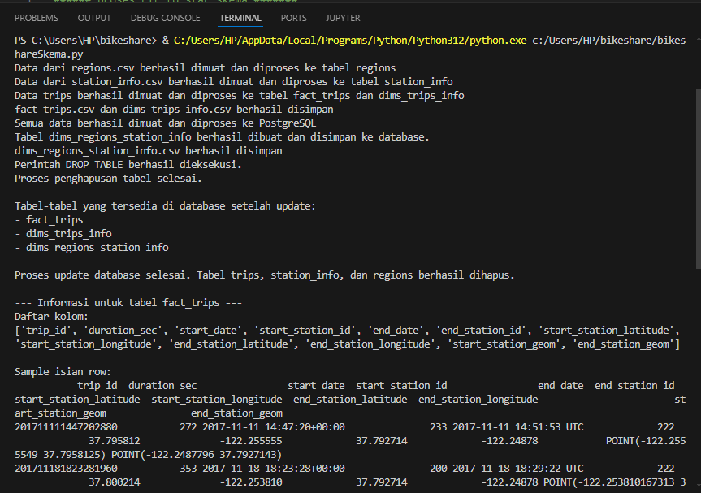

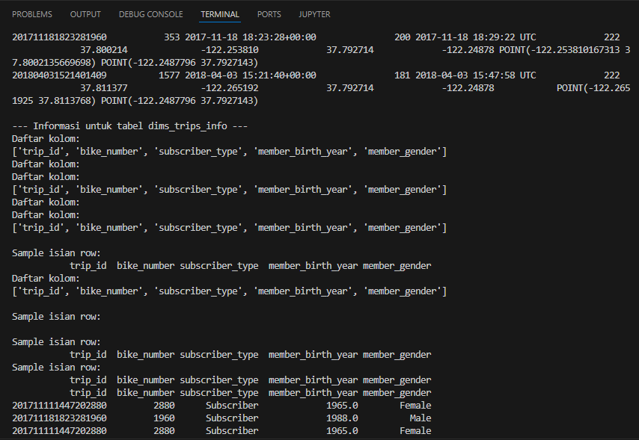

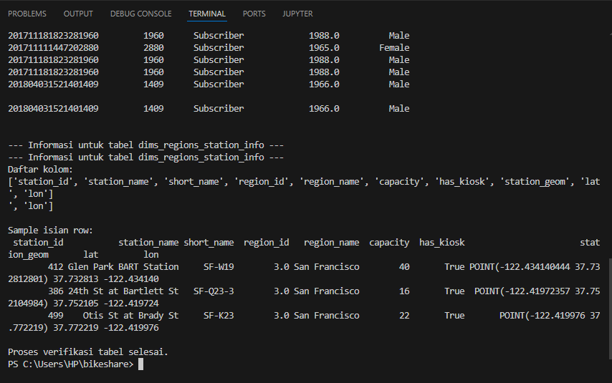

1. bikeshareMatrix.py >> proses skema to matrix

